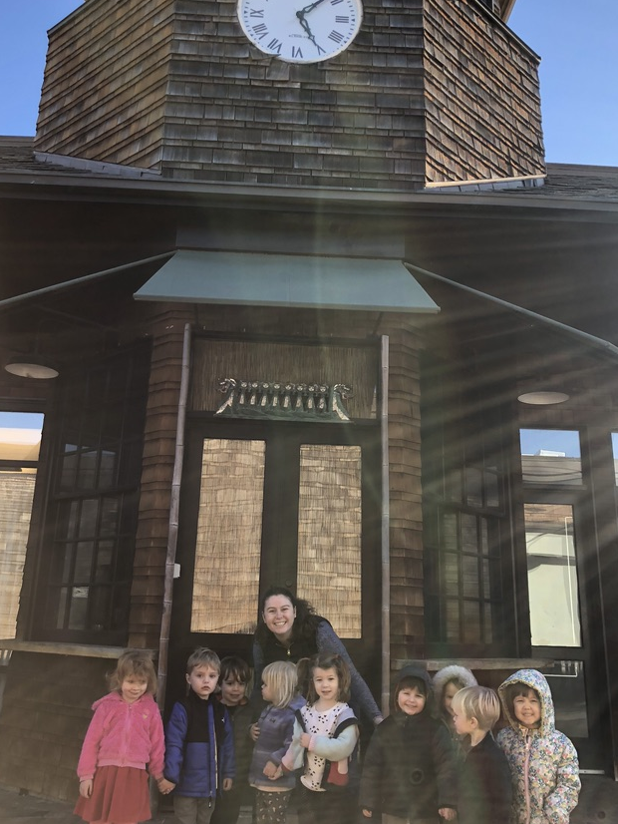
My what a busy and creative week it has been! As you all know the Willow room has been exploring building and measuring. This week we took a walk around the center to look at the sizes of the buildings. Below are a few conversations that transpired this week.

While on a walk around the center:
Lisa: “What do you all see?”
Miles: “I see the Bundt cake store, but it’s closed”
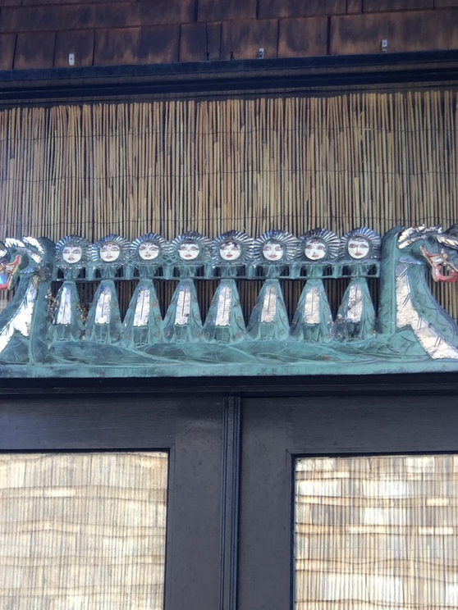
Parker: “Look at that giant clock, it has two hands!”
Emma: “What do you think this building is for with the clock?”
Emmy: “People live in there”

Willow Journal
February 7, 2019 Written By: Emma
Emma: “Oh who lives or works in this building?”
Will: “They play shows in their like Fire Sam. Fire sam lives in there!”
Sadie then mentions. “Dragons, like that one.”
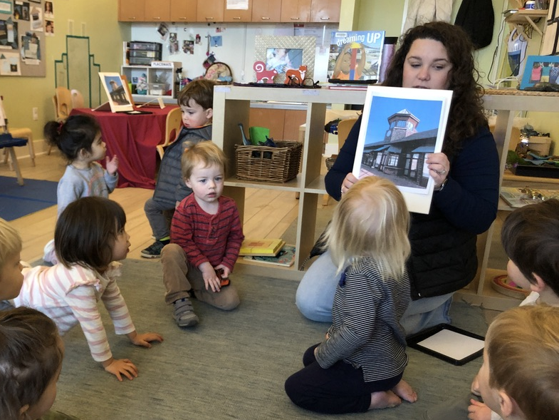
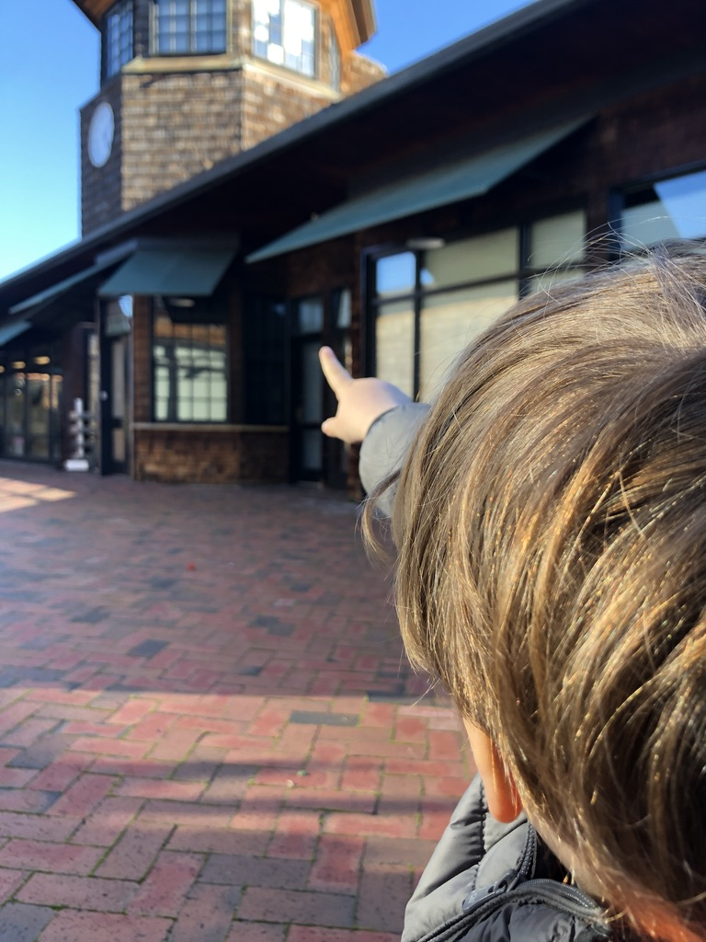
Sadie points to a dragon hanging over the door and instantly the children are hooked on dragons. This conversation stuck with the children throughout the week. During morning exploration on Wednesday and Thursday we set up an observational drawing for children to try drawing the clock tower building using shapes. Curtis was very insistent on seeing the dragon, so we went exploring to find the dragon again. Right as Curtis stepped outside the doors he points to the building with the clock and says, “Look it’s the castle. That’s where the dragon is. Let's go teacher. Curtis is so happy!” When we found the dragon we made sure to take photos and document what the dragon statue looked like so we could discuss it with everyone at circle.

During circle:
Emma: “Does anyone remember what we found while on our walks this week?”
Curtis: ”Dragon and fire sam.”
Will: “And the clock.”
Emma: “What was inside.”
Will: “The clock with fire sam.”
Isabella: “The clock.”
Parker: “How do you get up to the clock?”
Will: “A ladder, it’s inside. Fire Sam has a ladder.”
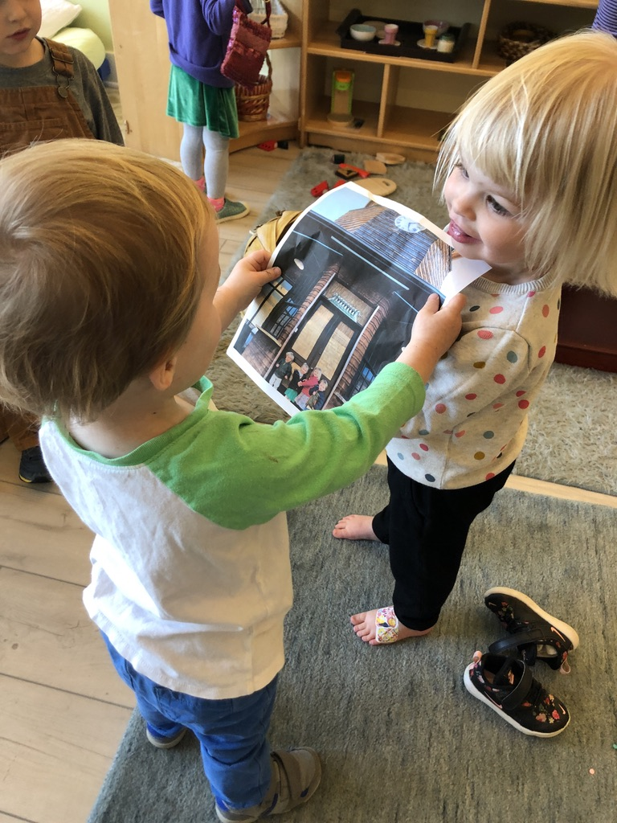
Emma: “What is in between the dragons in the photo that we took?”
Parker: “Person! Many persons I will count them. 1,2,3,4,5,6,7,8. 8 people!”
As we continue discussing the dragons, we notice the people between the dragons are holding their hands like they are taking a peace breath.
Jacki: “Do you think dragons take peace breaths too?”
Parker: “Yeah they do dragon breaths like this.” Parker then creates her own dragon breath. Everyone in the room loved it and we all tried it together. I encourage you to ask your children what a dragon breath is and if they can remember how to do it!
This has been a very exciting week because we are quickly seeing a project beginning to emerge. The level of excitement and curiosity from the Willows was contagious, and it was great to see them all wanting to participate in conversations and explorations at the tables. Conversations like the ones above are an important part of a Reggio inspired school because this week was based off of their interests. We started out by talking about buildings and as teachers we never would have thought that we would be ending the week talking about dragons. Children’s interests is what drives our curriculum forward and is an integral part of our school. I personally can’t wait to see how this project continues!
Activities Materials
Butterfly symmetry Felt
Cloud dough gems
Observational glow tower Drawing pen/paper
Ocean scene Ocean animals

